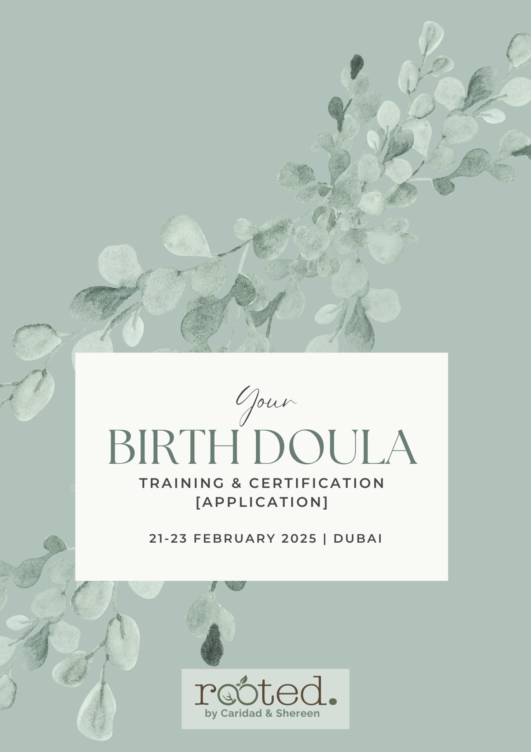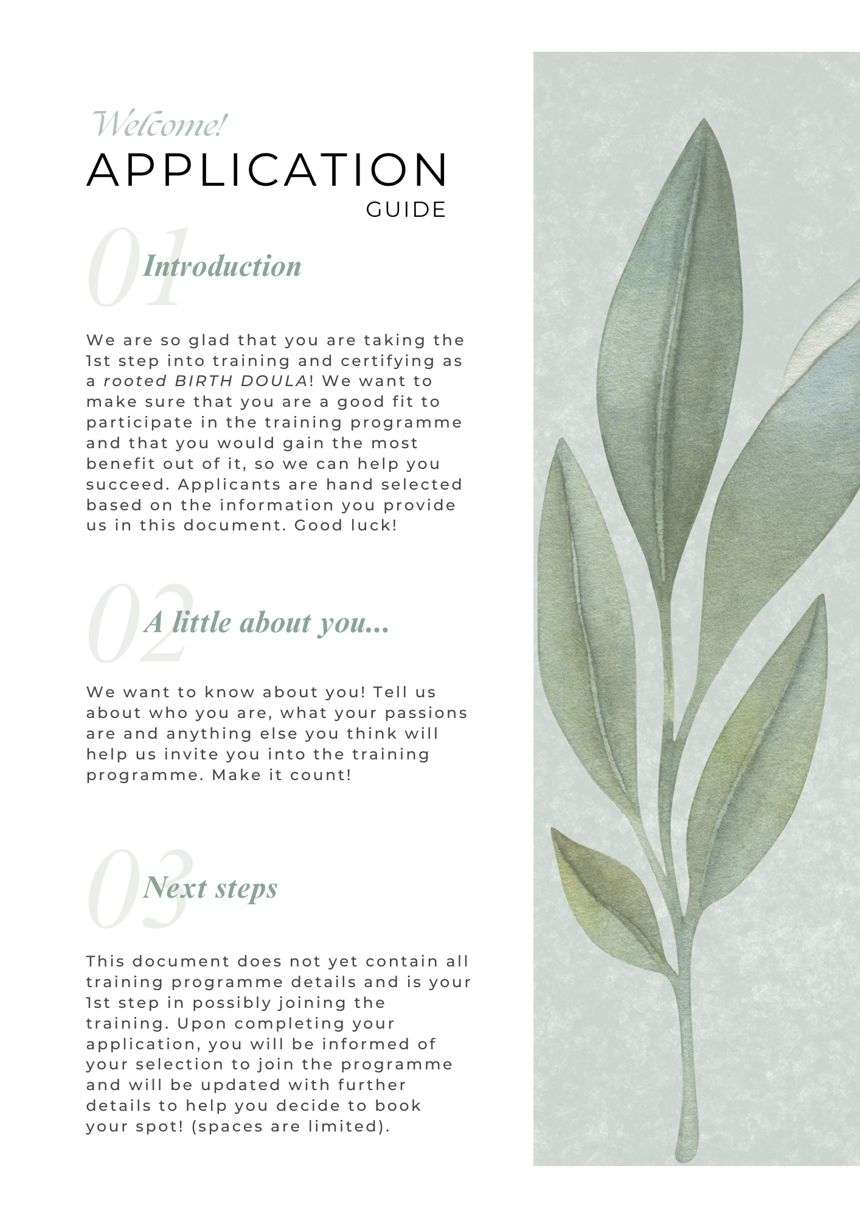

### 

### 

### **Personal Information**

Full Name:

|  |
| --- |
|  |

Age:

|  |
| --- |
|  |

Nationality:

|  |
| --- |
|  |

Spoken languages:

|  |
| --- |
|  |

Mobile/Whats app no. :

|  |
| --- |
|  |

Email address:

|  |
| --- |
|  |

Instagram account (if any?):

|  |
| --- |
|  |

### **Educational Background**

Please let us know of any educational qualifications you may have (in ANY field):

|  |
| --- |
|  |

### 

### **Work experience**

Please let us know of any work experience you may have (in ANY field):

|  |
| --- |
|  |

### **Personal status *(only for reference)***

* Married / have a partner
* I have a child / children

*If you have children, please indicate how many children you have:*

|  |
| --- |
|  |

### **Birth experience *(if applicable)***

Do you have a personal birth experience/s:

|  |
| --- |
|  |

If yes, would you describe your birth/s as *positive* or *negative* experience/s?

|  |
| --- |
|  |

Did you have Doula support?

|  |
| --- |
|  |

Did you attend any antenatal / birth preparation classes during pregnancy?

|  |
| --- |
|  |

### 

### **Your BIRTH DOULA interest**

Why do you wish to train and certify as a Birth Doula?

|  |
| --- |
|  |

What do you hope to learn in your Birth Doula training programme?

|  |
| --- |
|  |

Why are you interested to train with ‘rooted’ *(Caridad & Shereen)*?

|  |
| --- |
|  |

Anything else you would like to include?

|  |
| --- |
|  |

Thank you! Please email us back your filled in application form to **rooteduae@gmail.com**

|  |
| --- |
| *"If a doula were a drug, it would be unethical not to use it.”*  – John H. Kennel, MD |